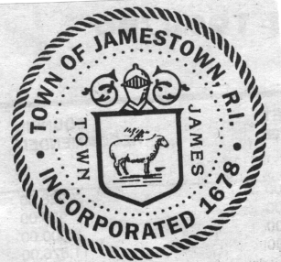

Jamestown, Rhode Island

NOTICE

It is hereby given by the Town Council of the Town of Jamestown, being the Licensing Board in said Town as provided under Title 3, Chapters 1-12 of the General Laws of Rhode Island 1956, and as amended, that the following application has been received by the Town Council for the NEW license under said Act, for the period July 8, 2019 to November 30, 2019.

NEW LICENSE:
CLASS B – VICTUALER
Our Table, LLC
dba: Our Table
29 Narragansett Avenue
Jamestown, RI 02835

The above application will be in order for hearing at a meeting of said Licensing Board on Monday, July 8, 2019 at 6:30 p.m. at the Jamestown Town Hall, Rosamond A Tefft Council Chambers, 93 Narragansett Avenue, in said Jamestown, at which time and place all remonstrants may make their objections against granting this license.

By Order of the Town Council
Cheryl A. Fernstrom, CMC, Town Clerk
This meeting location is accessible to the physically challenged. If communications assistance is needed or other accommodations to ensure equal participation, please call 1-800-745-5555, or contact the Town Clerk at 401-423-9800, via facsimile to 401-423-7230, or email to cfernstrom@jamestownri.net not less than three (3) business days prior to the meeting.

Advertisement in the Jamestown Press editions of June 20 and 27, 2019

