Social Security Scam Awareness – 2020
Third Party Social Media Toolkit

What is Scam Awareness?
Social Security takes protecting your personal information seriously. We are aware that there have been many telephone scammers pretending to be government employees and is continuing to spread worldwide. We are working with the Inspector General of Social Security to do the following:
- Inform and educate the public about phone scams.
- Explain how to avoid phone scams.
- Encourage them to report phone scams.
Please join us in promoting these messages, tools, and educational materials through our online services. We are currently posting about these phone scams on multiple social media outlets. They include:
- YouTube
- Social Security Matters blog
- Twitter
- Facebook
- LinkedIn
- SeguroSocial Facebook
- SeguroSocial Twitter
- Instagram
We appreciate your partnership and support!

Available messaging and social media posts:

Facebook
  - Social Security takes protecting your personal information seriously. Please see this important message from the Commissioner on how to protect yourself from phone scams: http://ow.ly/1HEM50xIgDU
  - Beware of Social Security phone scams! Telephone scammers are pretending to be government employees. You can report scams here: http://ow.ly/tKpn50y1ZMh.
  - What should I do if I get a call claiming there's a problem with my Social Security number or account? Check out this Social Security FAQ for the answer: http://ow.ly/kFjZ50yt0mo

Twitter
  - Watch this video http://ow.ly/x5Pa50yAfYZ on how to identify #SocialSecurity scammers. Read our fact sheet for more tips on how to protect yourself here: http://ow.ly/PrUw50xOmqD. Please share this with family and friends.
  - Beware of Social Security phone scams! Telephone scammers are pretending to be government employees. You can report scams here: http://ow.ly/tKpn50y1ZMh.
  - What should I do if I get a call claiming there's a problem with my #SocialSecurity number or account? Check out this @SocialSecurity #FAQ for the answer: http://ow.ly/GWQV50yt0nL

LinkedIn
  - Social Security takes protecting your personal information seriously. Please see this important message from the Commissioner on how to protect yourself from phone scams: http://ow.ly/1HEM50xIgDU
  - Beware of Social Security phone scams! Telephone scammers are pretending to be government employees. You can report scams here: http://ow.ly/tKpn50y1ZMh.
  - What should I do if I get a call claiming there's a problem with my Social Security number or account? Check out this Social Security FAQ for the answer: http://ow.ly/qLkt50yt0pS

SeguroSocial Facebook
  - Esa llamada no vino de nosotros. Evite ser víctima de los estafadores. Infórmese mejor sobre cómo proteger su información personal leyendo nuestro comunicado de prensa http://ow.ly/98nW50xhZoc. Comparta esta información con sus amigos y familiares.

SeguroSocial Twitter
  - Esa llamada no la hicimos nosotros. Lea nuestro artículo sobre llamadas de estafadores http://ow.ly/Sdy050xkWIT

YouTube
  - 15 second PSA - https://www.youtube.com/watch?v=VloReuZ6VzQ
  - 30 second PSA - https://www.youtube.com/watch?v=QJVm_hWb6Uo
  - 60 second PSA - https://www.youtube.com/watch?v=QrHFNdjcp2s

Social Security Matters Blog Articles
  - Social Security Launches New Campaign to Fight Scammers
  - Inspector General Warns Public About New Twist To Social Security Phone Scams
  - Beware of Social Security Scams

Images
Figure 1 -
Social Security Phone Scam Public Service Announcement (PSA), featuring Andrew Saul, Commissioner of Social Security
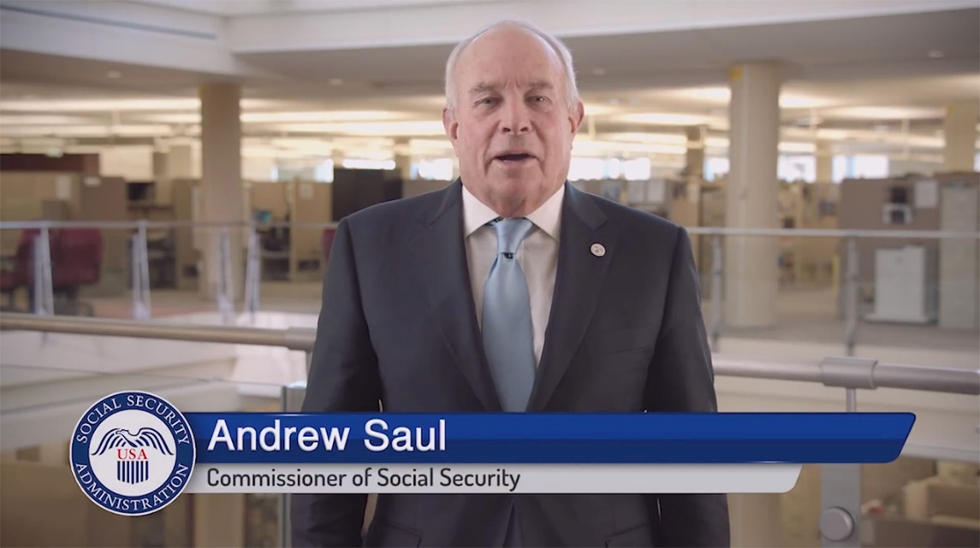
Figure 2 -
Generic branded Image “Securing today and tomorrow”
Figure 3 –
Public Trust Quote - Andrew Saul, Commissioner of Social Security
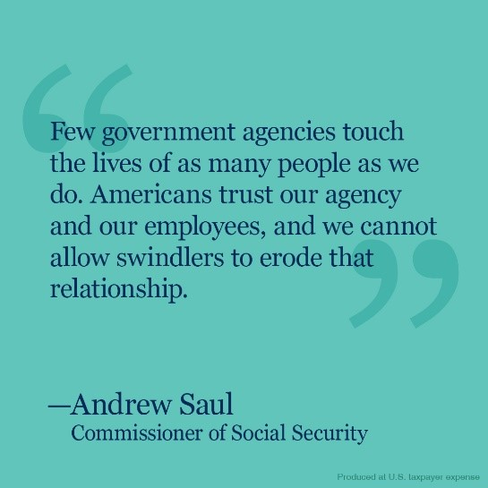
Figure 4 –
Banner 1 - Beware of Social Security Phone Scams
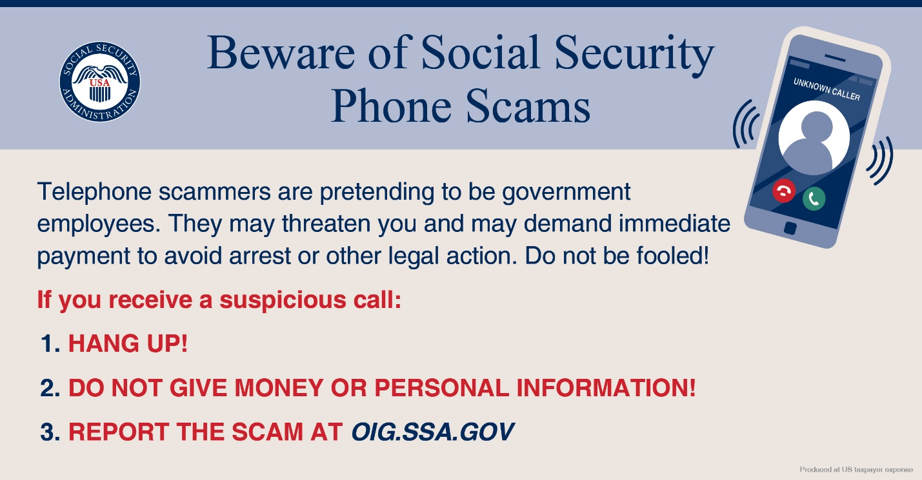
Figure 5 –
Banner 2 - Beware of Social Security Phone Scams
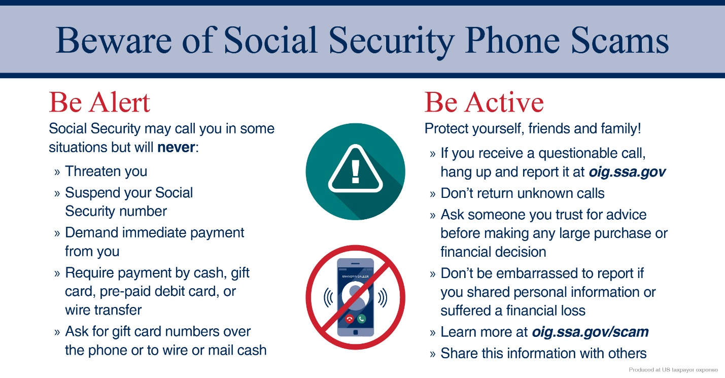

Live Post Links for you to share or retweet directly
from our channels

Facebook:
Post: Beware of scams and caller-ID “spoofing” schemes! Learn how to protect yourself from fraudsters here: http://ow.ly/qBJz50yc0hi
Link for sharing:
https://www.facebook.com/socialsecurity/posts/10158167268930288?__xts__[0]=68.ARBSztKjVoNL8XSbUGVTUIrhlA_O0oNgd3lQ5Ps-qoDVRtMcGOJhMa7swTGlrDjDqIW3i_NJk4aPE7dhTi1alWt59zLXhc-aVIeBQ1Y747zVdijEVkUOUvhkLD2ehvzagqq0ExccDZn_GZNNgCHXQm1lzRQYNwsG0fU2ubHFO6UhS92aNwNnFn49Qcg57BXchGPc_GvkCDcr5Ab4QtqMO0-p4-bfjyp3Kh8trZulrwMyD5diJHhXV3oQfYdLGvtBJzN-Aq6Y6wgXjjZSMDQTABGlNg-OvVYCdaX5VtPwZttE5AMDE-SstXOk4MYpQYywHo83LojfBbK4Lg&__tn__=-R
Post: Don’t fall victim to scammers. Learn how you can protect your information at #SocialSecurityMatters: http://ow.ly/NOyG50xhogX #Fraud #Scams #SocialSecurity
Link for sharing:
https://www.facebook.com/socialsecurity/posts/10158140404570288?__xts__[0]=68.ARDadtfa_ERB04TvoLfE1gtFQGpgMfr-8v5a10naR4khx97PltvpFSw8CVgt20AF9W3D-WS8A2azm6kJ0aiI2C9DbzHEsWkx2W1Ns787M73RCLoUHNvvyLB4VgPd-mGqoUoCfJOsgbzre3Ad5nfGwprFVCXoGybMIbGxAGd8mIiHfjzbLbr1fQ6ErwhQEjl1zzNhyemI3isexiVTSJsiu8bkY0WhJl84yiJo40XQWgKa-SRCmmxszi-pJ3TPfYNUU_LgOOhxsHfBwJ8clojj-v739gOvWwdKQ4PbVfBatWHMy5TOveR5HWoCAGZ9uwDunBrOChKCHMseUqXCg3N_nVUwiFGkFpOMHPf10_-hE0nQzaa_BBL1HpbjHBRC1rHOlrxJk2elQ_XhDMG2vhwSEw3ZMFoqjWZvUj3bCQLy3-ThdG9TQmcopS28oCUbX_N4h6y9gWuvNwZ7S-3hMXLnvHj8tPmKRtCS_9Ap2RpuAA&__tn__=-R
Post: That call is not from us. Don’t fall victim to scammers. Learn how you can protect your information at #SocialSecurityMatters: http://ow.ly/NOyG50xhogX #Fraud #Scams #SocialSecurity
Link for sharing:
https://www.facebook.com/socialsecurity/photos/a.163207280287/10158124409220288/?type=3&av=64443335287&eav=AfZQGV0uTY8SiDuCrF0P6Q7jDybxlQsnE6QPccCg2umEaP7zJEoCNvsf29farAupC_c&theater

Twitter
Post: #SocialSecurity recently launched a new campaign on how to fight against scammers. Learn more on our #SocialSecurityMatters blog: http://ow.ly/4Xuo50ylOKR pic.twitter.com/bnJWGMcOln
Link for sharing:
https://twitter.com/SocialSecurity/status/1228028687339139075
Post: Social Security takes protecting your personal information seriously. Please see this important message from the Commissioner on how to protect yourself from phone scams: http://ow.ly/bCBa50xKftW
Link for sharing:
https://twitter.com/SocialSecurity/status/1220376982686519299

