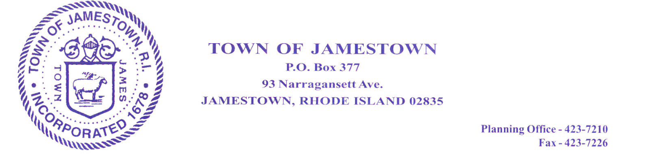

GOULD ISLAND RESTORATION ADVISORY BOARD
November 12, 2020
6:30 PM

PURSUANT TO EXECUTIVE ORDER NO. 20-46 EXECUTED BY GOVERNOR GINA RAIMONDO ON MARCH 16, 2020
THIS MEETING WILL BE TELECONFERENCED VIA ZOOM:
The public is invited to observe the deliberations of this meeting by accessing the meeting link set forth herein. For those without access to video observation platforms, you may also call in to listen to the deliberations of this meeting by using the call-in phone number provided herein. To participate during Public Hearing or Public Input you will press *9 to raise your hand.

Join Zoom Meeting
https://us02web.zoom.us/j/85905712512

Meeting ID: 859 0571 2512
One tap mobile
+13017158592,,85905712512# US (Germantown)
+13126266799,,85905712512# US (Chicago)

Dial by your location
+1 301 715 8592 US (Germantown)
+1 312 626 6799 US (Chicago)
+1 646 558 8656 US (New York)
+1 253 215 8782 US (Tacoma)
+1 346 248 7799 US (Houston)
+1 669 900 9128 US (San Jose)
833 548 0276 US Toll-free
833 548 0282 US Toll-free
877 853 5247 US Toll-free
888 788 0099 US Toll-free
Meeting ID: 859 0571 2512
Find your local number: https://us02web.zoom.us/u/k0qJvR6Ap

