A 4-week experience
AGING GRACEFULLY AND GRATEFULLY
Lessons Learned: My story's not done

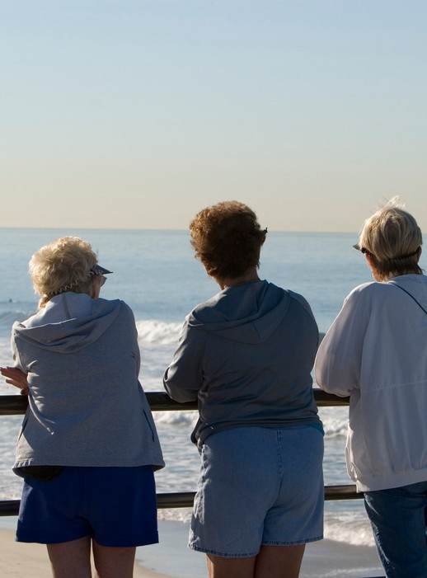
Discussion Topics:

Major Life Changes Life Lessons
Self Care
Life Purpose Ageism
Reflection
Fridays 1:30-2:30
January 5, 12, 19, 26,2024
The Jamestown Senior Center - downstairs Cost: $40 for the series
Facilitator: Diane Westerman,MA
RSVP: Molly at 401 423-9804

